**Sentiment Analysis on United States Senate Election, Ohio 2018**

**Introduction:**

Twitter is a popular social blogging website. Tweets are most helpful for analyzing a person perspective. The main challenge is to mine the data and summarize the ideas on tweets. In this project, I have collected tweets related to US Senate Elections Ohio 2018 and performed sentiment analysis using python. So, to do this we have processed unstructured raw data from Twitter and processed it to semi-structure data.

**Steps Followed:**

1. Create a twitter application
2. Extract tweets using search term
3. Preprocess tweets
4. Import tweets in mongodb
5. Analyze tweets by performing sentiment analysis
6. Visualizing the results

**Creating Twitter Application:**

To access twitter API, we need to create twitter application by providing required details.

Once the application is created, you will get required keys and tokens to access twitter API.

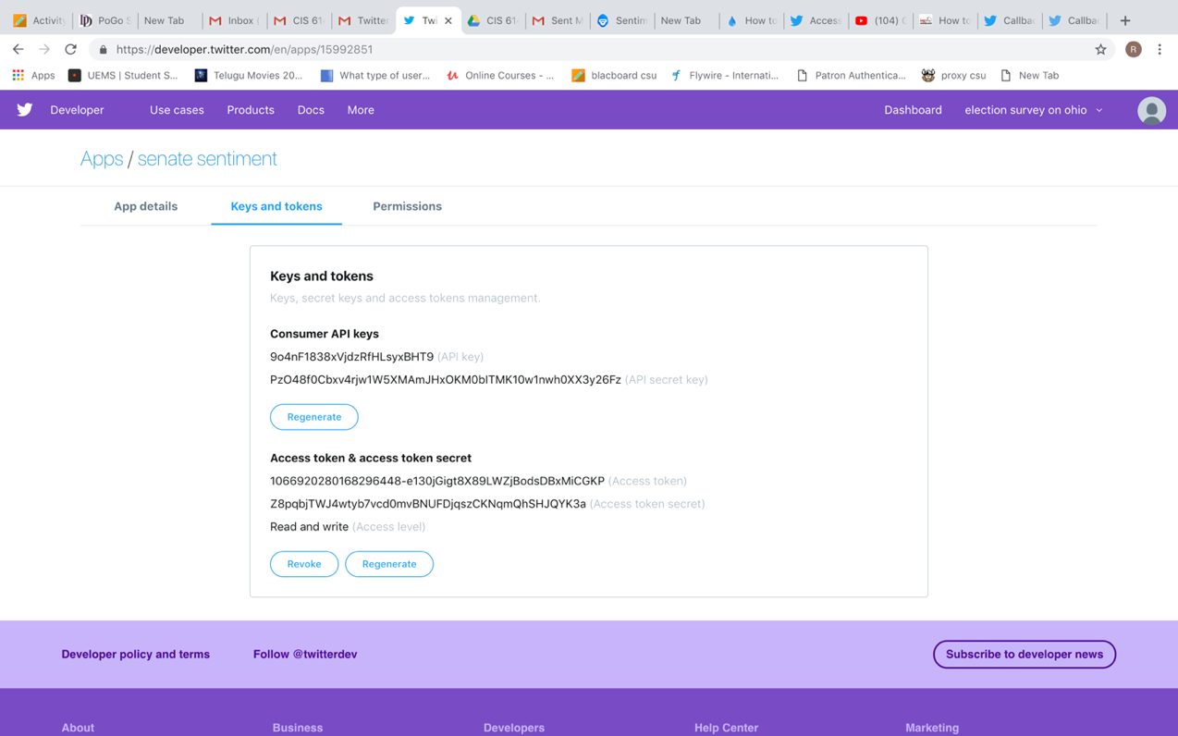

**Extraction of tweets:**

I used python programming language to access twitter API. Python provides a library called tweepy to work with twitter API.

Below is the installation of tweepy

Navigate to python/scripts folder and type pip install tweepy

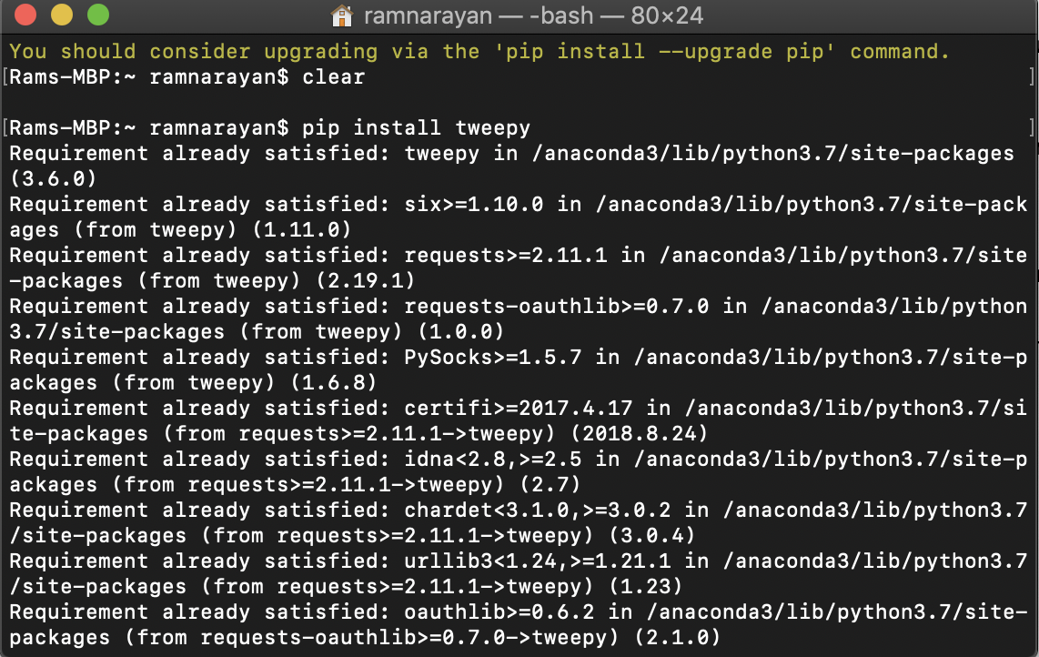

**Program to collect tweets using tweepy:**

Import tweepy

Import jsonpickle

ckey=' 9o4nF1838xVjdzRfHLsyxBHT9 '

csecret='PzO48f0Cbxv4rjw1W5XMAmJHxOKM0bITMK10w1nwh0XX3y26Fz'

atoken='1066920280168296448-e130jGigt8X89LWZjBodsDBxMiCGKP'

asecret=' Z8pqbjTWJ4wtyb7vcd0mvBNUFDjqszCKNqmQhSHJQYK3a '

auth=tweepy.OAuthHandler(ckey,csecret)

auth.set_access_token(atoken,asecret)

api = tweepy.API(auth,wait_on_rate_limit=True)

count = 0

﻿file=open('/Users/ramnarayan/Desktop/twitterdata/OhioSenate1.json','a')

for tweet in tweepy.Cursor(api.search,q="#SherrodBrown OR #OhioSen OR #OhioPrimary OR @Repjimrenacci",lang="en").items():

file.write(jsonpickle.encode(tweet._json,unpicklable=False) +'\n')

count= count +1

print("total count",count)

We collected tweets into JSON file using jsonpickle. Jsonpickle is python library that saves the json data into json file.

jsonpickle is a python library for serialization and deserialization of complex python objects to and from JSON. The standard python libraries for encoding python into JSON.

**Installation of jsonpickle:**

Install jsonpickle using pip install -U jsonpickle

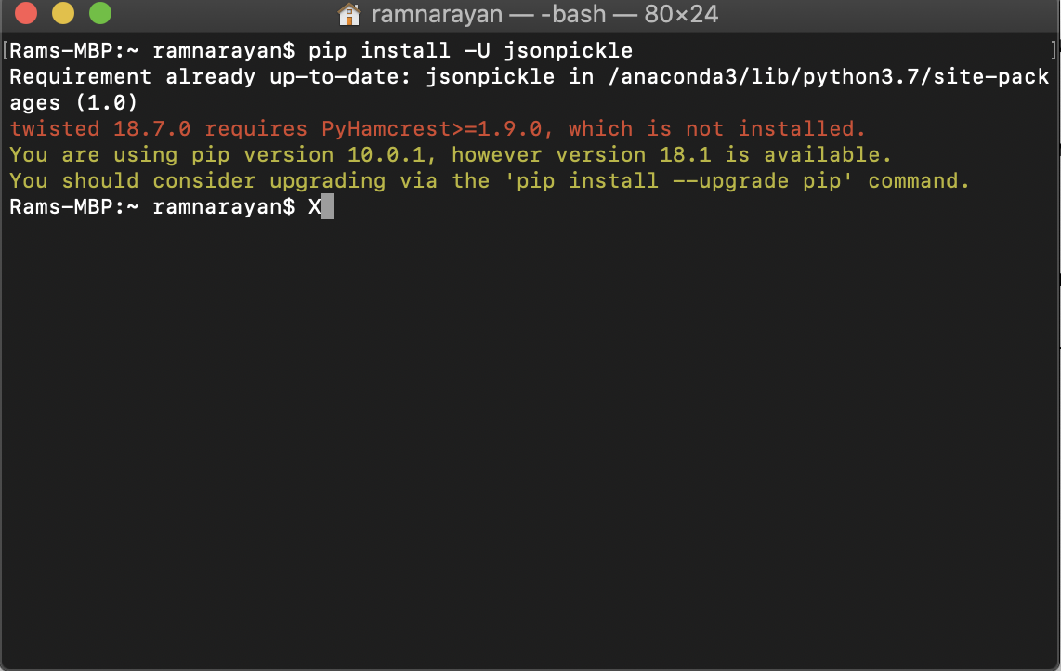

I have collected tweets for Democratic member Sherrod Brown who won the senate election and the opponent Republican JimRenacci and created a jsonfile individually.

I have extracted tweets for JimRenacci using the same code but by changing hashtags

﻿ Import tweepy

Import jsonpickle

ckey=' 9o4nF1838xVjdzRfHLsyxBHT9 '

csecret='PzO48f0Cbxv4rjw1W5XMAmJHxOKM0bITMK10w1nwh0XX3y26Fz'

atoken='1066920280168296448-e130jGigt8X89LWZjBodsDBxMiCGKP'

asecret=' Z8pqbjTWJ4wtyb7vcd0mvBNUFDjqszCKNqmQhSHJQYK3a '

auth=tweepy.OAuthHandler(ckey,csecret)

auth.set_access_token(atoken,asecret)

api = tweepy.API(auth,wait_on_rate_limit=True)

count = 0

﻿file=open('/Users/ramnarayan/Desktop/twitterdata/OhioSenate2_new.json','a')

for tweet in tweepy.Cursor(api.search,q="#JimRenacci OR #OhioSen OR #OhioPrimary OR @Repjimrenacci",lang="en").items():

file.write(jsonpickle.encode(tweet._json,unpicklable=False) +'\n')

count= count +1

print("total count",count)

Below is the jsonfile we collected for Sherrod Brown

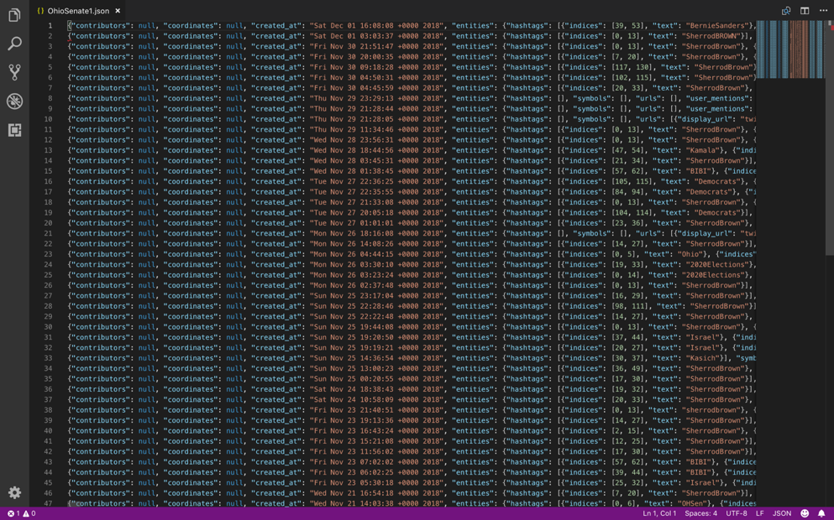

Below Jsonfile we collected for JimRenacci

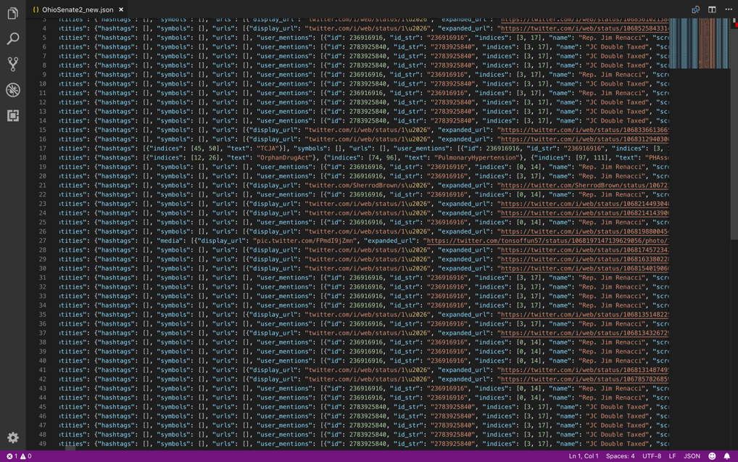

We imported the JSON file created using above program into mongodb

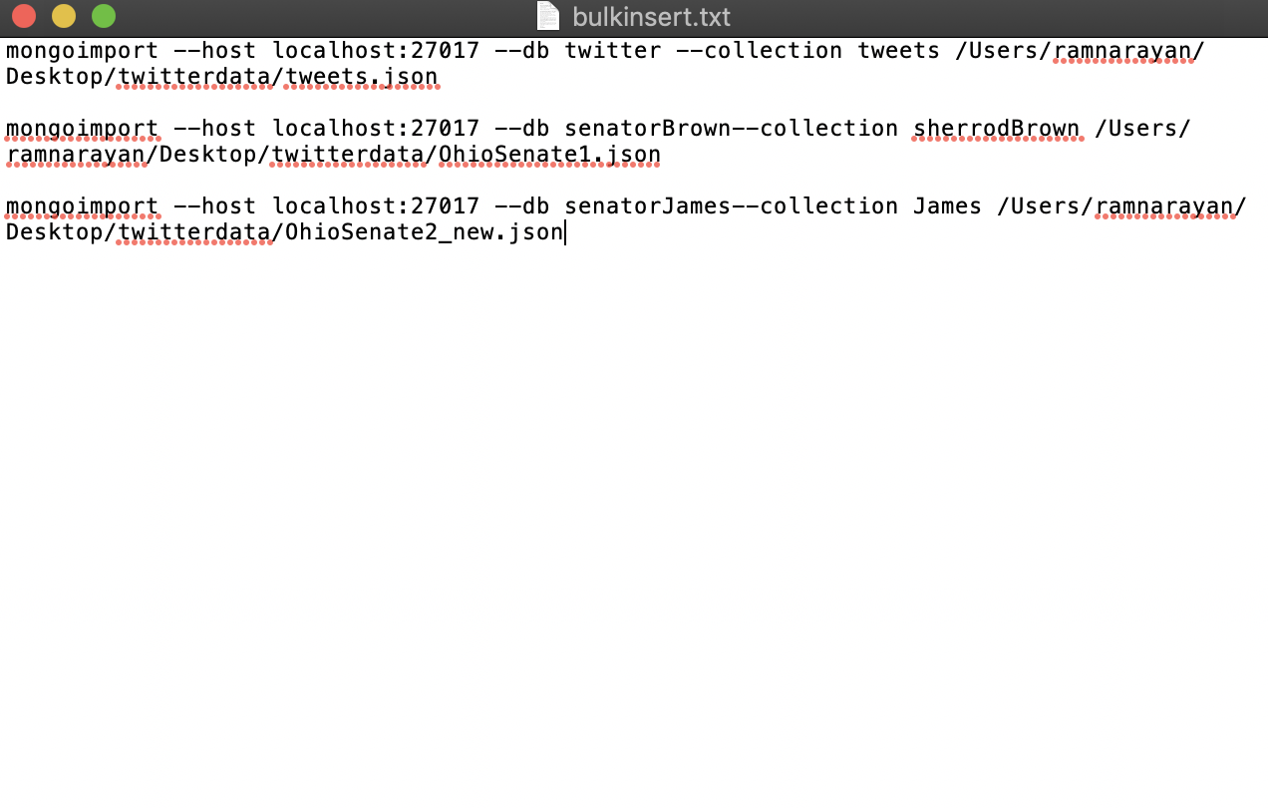

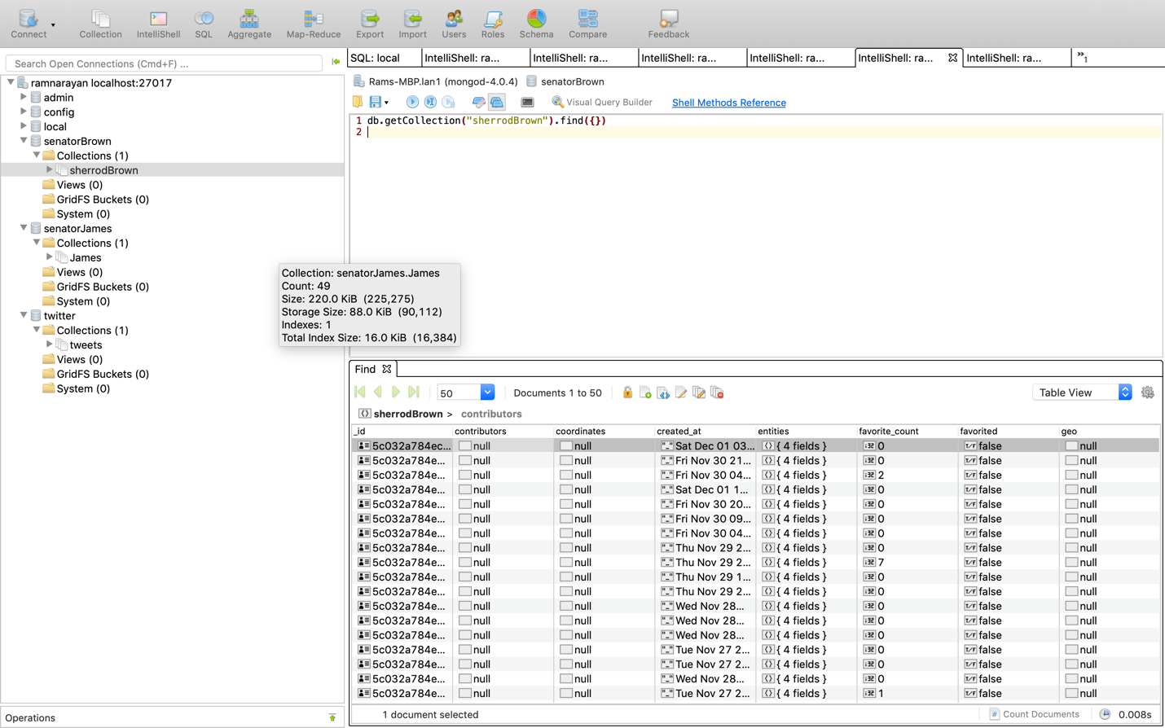

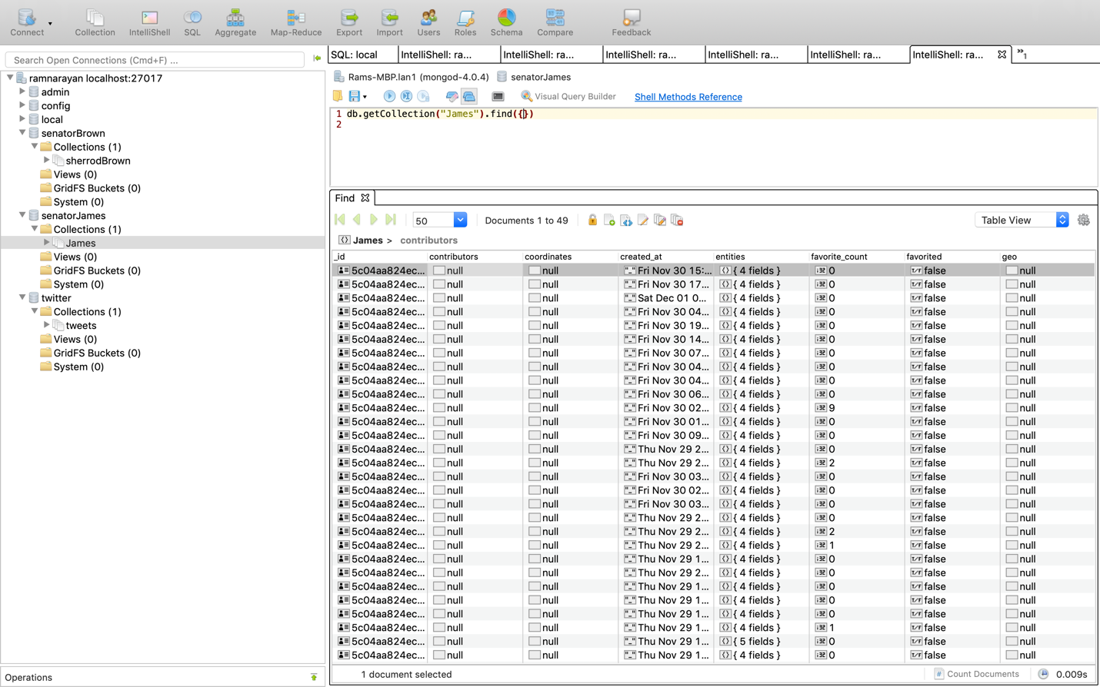

**Sentiment analysis using mongodb and python:**

I wrote a program that connects to mongodb twitter collection, and for each tweet, it retrieves, it performs sentiment analysis. Below is the code that performs the task

import sys,tweepy,csv,re

import matplotlib.pyplot as plt

from textblob import TextBlob

from pymongo import MongoClient

class SentimentAnalysis:

#global initialization of variables

def __init__(self):

self.tweets = []

self.tweetText = []

# method to get tweets from mongodb

def getTweets(self):

client = MongoClient('localhost', 27017)

db = client.senatorBrown

collection = db.senatorBrown

self.tweets =collection.find({})

NoOfTerms=collection.count()

print("Total number of tweets",NoOfTerms)’

﻿searchTerm = "Eelections2018 Brown"

# Open/create a file to append data to

csvFile = open('result.csv', 'a')

# Use csv writer

csvWriter = csv.writer(csvFile)

# creating some variables to store info

polarity = 0

positive = 0

wpositive = 0

spositive = 0

negative = 0

wnegative = 0

snegative = 0

neutral = 0

# iterating through tweets fetched and assigning sentiment

for tweet in self.tweets:

self.tweetText.append(self.cleanTweet(tweet["text"]).encode('utf-8'))

analysis = TextBlob(tweet["text"])

polarity += analysis.sentiment.polarity # adding up polarities to find the average later

if (analysis.sentiment.polarity == 0): # adding reaction of how people are reacting to find average later

neutral += 1

elif (analysis.sentiment.polarity > 0 and analysis.sentiment.polarity <= 0.3):

wpositive += 1

elif (analysis.sentiment.polarity > 0.3 and analysis.sentiment.polarity <= 0.6):

positive += 1

elif (analysis.sentiment.polarity > 0.6 and analysis.sentiment.polarity <= 1):

spositive += 1

elif (analysis.sentiment.polarity > -0.3 and analysis.sentiment.polarity <= 0):

wnegative += 1

elif (analysis.sentiment.polarity > -0.6 and analysis.sentiment.polarity <= -0.3):

negative += 1

elif (analysis.sentiment.polarity > -1 and analysis.sentiment.polarity <= -0.6):

snegative += 1

# finding average of how people are reacting

positive = self.percentage(positive, NoOfTerms)

wpositive = self.percentage(wpositive, NoOfTerms)

spositive = self.percentage(spositive, NoOfTerms)

negative = self.percentage(negative, NoOfTerms)

wnegative = self.percentage(wnegative, NoOfTerms)

snegative = self.percentage(snegative, NoOfTerms)

neutral = self.percentage(neutral, NoOfTerms)

# finding average reaction

polarity = polarity / NoOfTerms

# printing out data

print("How people are reacting on " + searchTerm + " by analyzing " + str(NoOfTerms) + " tweets.")

print()

print("General Report: ")

if (polarity == 0):

print("Neutral")

elif (polarity > 0 and polarity <= 0.3):

elif (analysis.sentiment.polarity > -0.6 and analysis.sentiment.polarity <= -0.3):

negative += 1

elif (analysis.sentiment.polarity > -1 and analysis.sentiment.polarity <= -0.6):

snegative += 1

# finding average of how people are reacting

positive = self.percentage(positive, NoOfTerms)

wpositive = self.percentage(wpositive, NoOfTerms)

spositive = self.percentage(spositive, NoOfTerms)

negative = self.percentage(negative, NoOfTerms)

wnegative = self.percentage(wnegative, NoOfTerms)

snegative = self.percentage(snegative, NoOfTerms)

neutral = self.percentage(neutral, NoOfTerms)

# finding average reaction

polarity = polarity / NoOfTerms

# printing out data

print("How people are reacting on " + searchTerm + " by analyzing " + str(NoOfTerms) + " tweets.")

print()

print("General Report: ")

if (polarity == 0):

print("Neutral")

elif (polarity > 0 and polarity <= 0.3):

print("Weakly Positive")

elif (polarity > 0.3 and polarity <= 0.6):

print("Positive")

elif (polarity > 0.6 and polarity <= 1):

print("Strongly Positive")

elif (polarity > -0.3 and polarity <= 0):

print("Weakly Negative")

elif (polarity > -0.6 and polarity <= -0.3):

print("Negative")

elif (polarity > -1 and polarity <= -0.6):

print("Strongly Negative")

print()

print("Detailed Report: ")

print(str(positive) + "% people thought it was Excellent")

print(str(wpositive) + "% people thought it was Enjoyable")

print(str(spositive) + "% people thought it was Remarkable")

print(str(negative) + "% people thought it was Bore")

print(str(wnegative) + "% people thought it was Waste")

print(str(snegative) + "% people thought it was Worst")

print(str(neutral) + "% people thought it was average")

self.plotPieChart(positive, wpositive, spositive, negative, wnegative, snegative, neutral, searchTerm, NoOfTerms)

#function to clean tweet text

def cleanTweet(self, tweet):

return ' '.join(re.sub("(@[A-Za-z0-9]+)|([^0-9A-Za-z \t]) | (\w +:\ / \ / \S +)", " ", tweet).split())

# function to calculate percentage

def percentage(self, part, whole):

temp = 100 * float(part) / float(whole)

return format(temp, '.2f')

#function that plots pie chat with the sentiments

def plotPieChart(self, positive, wpositive, spositive, negative, wnegative, snegative, neutral, searchTerm, noOfSearchTerms):

labels = ['Remarkable [' + str(spositive) + '%]','excellent [' + str(positive) + '%]', 'enjoyable [' + str(wpositive) + '%]', 'average [' + str(neutral) + '%]',

'Bore [' + str(negative) + '%]', 'Waste [' + str(wnegative) + '%]', 'Worst [' + str(snegative) + '%]']

sizes = [ spositive,positive, wpositive, neutral, negative, wnegative, snegative]

colors = ['darkgreen','yellowgreen','lightgreen', 'gold', 'red','lightsalmon','darkred']

patches, texts = plt.pie(sizes, colors=colors, startangle=90)

plt.legend(patches, labels, loc="best")

plt.title('How people are reacting on ' + searchTerm + ' by analyzing ' + str(noOfSearchTerms) + ' Tweets.')

plt.axis('equal')

plt.tight_layout()

plt.show()

if __name__== "__main__":

sa = SentimentAnalysis()

sa.DownloadData()

**Matplotlib:**

Matplotlib is a plotting library for the python programming language and its numerical mathematics extension NumPy. It provides an object-oriented API for embedding plots into applications using general-purpose GUI toolkits. We used Matplotlib python library for plotting pie chart.

**Installation of Matplotlib:**

Install Matplotlib using pip install matplotlib.

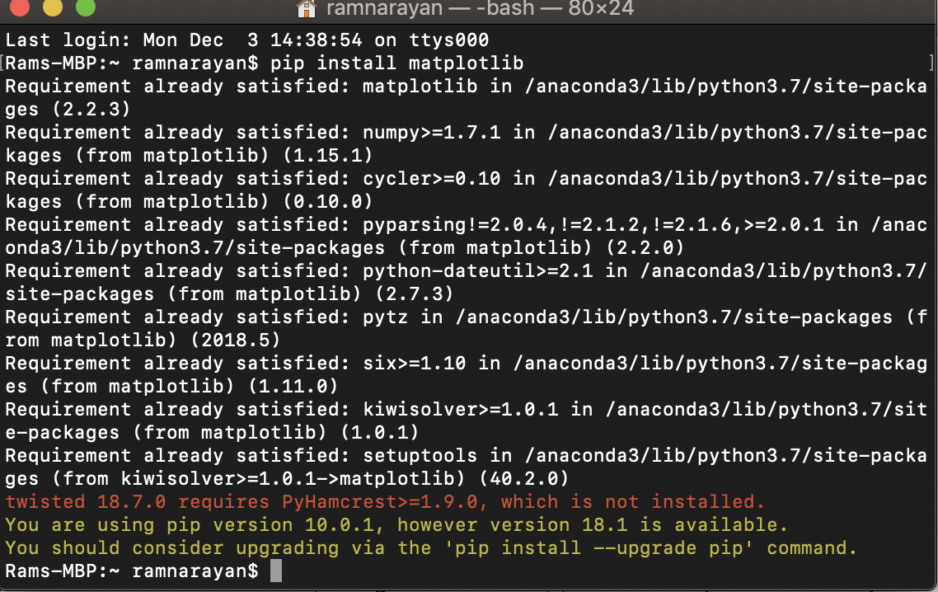

**Output:**

Results show that 24% tweets talk positive about the Sherrod Brown senate elections and 46% tweets talk neutral and 10% talk negative.

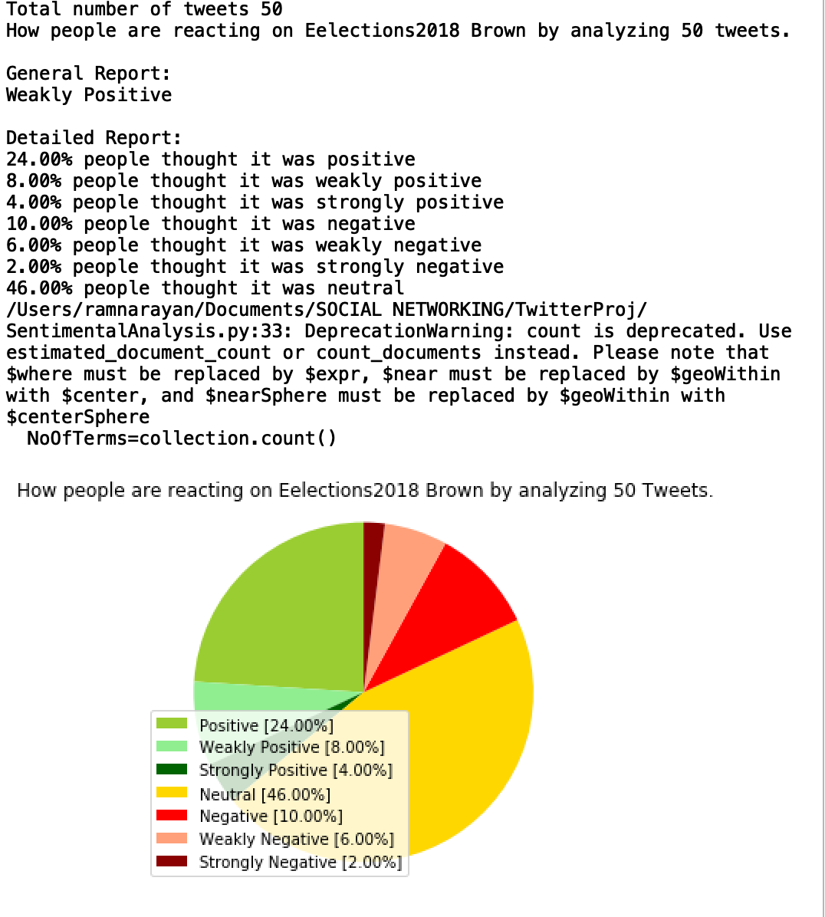

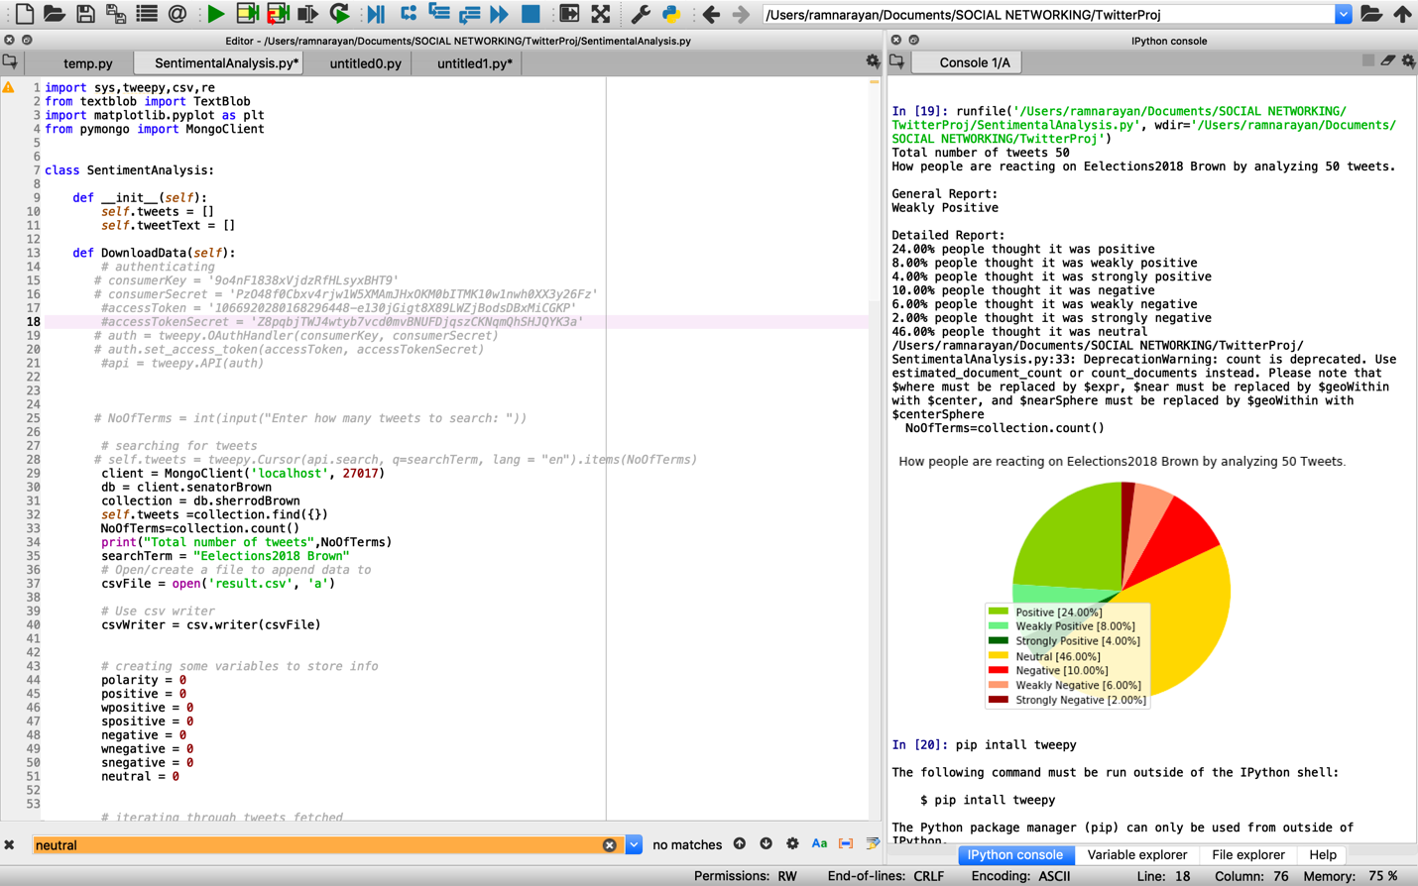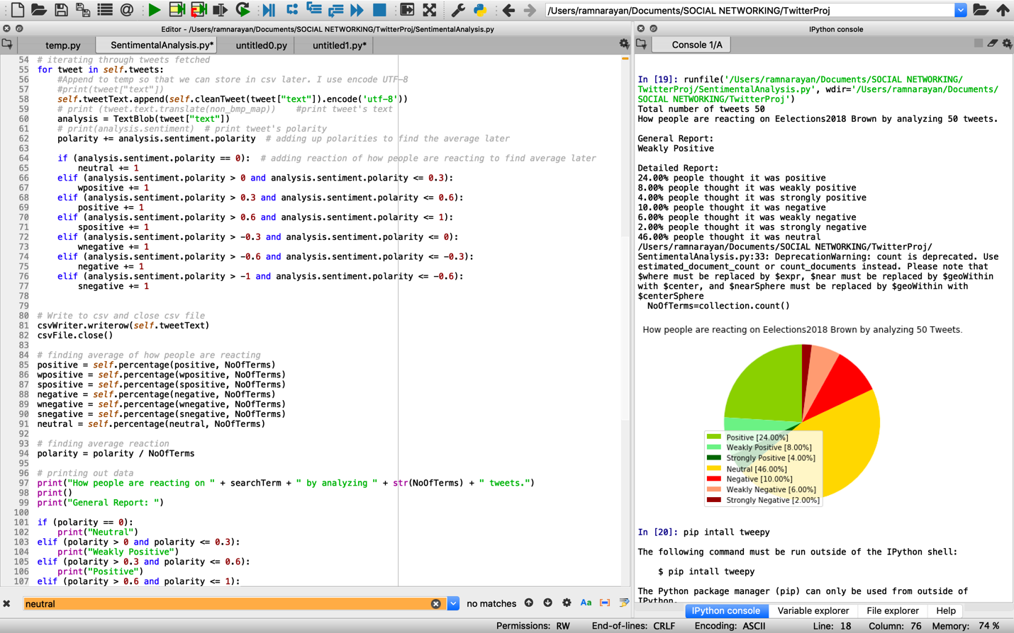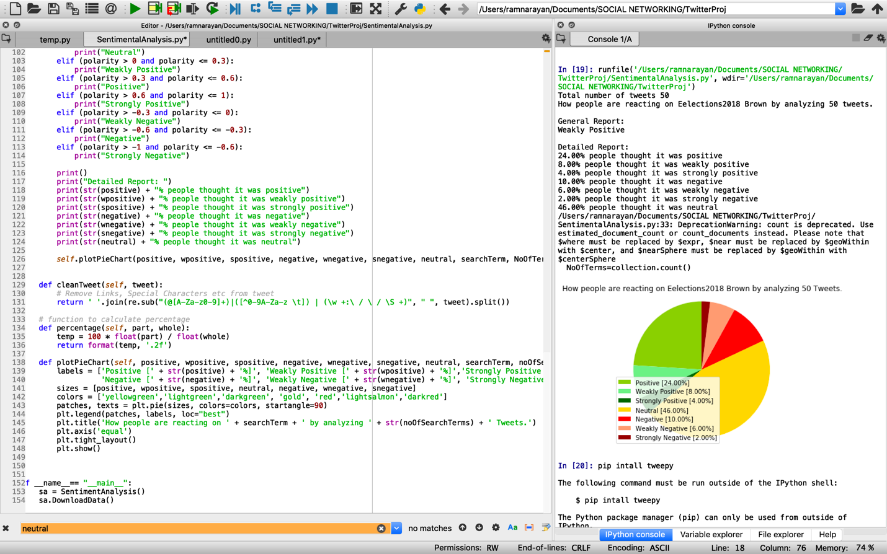

Now I have done sentiment analysis for Renacci’s twitter collection using the same code

Below is the code that performs the task

import sys,tweepy,csv,re

import matplotlib.pyplot as plt

from textblob import TextBlob

from pymongo import MongoClient

class SentimentAnalysis:

#global initialization of variables

def __init__(self):

self.tweets = []

self.tweetText = []

# method to get tweets from mongodb

def getTweets(self):

client = MongoClient('localhost', 27017)

db = client.senatorJames

collection = db.James

self.tweets =collection.find({})

NoOfTerms=collection.count()

print("Total number of tweets",NoOfTerms)’

﻿searchTerm = "Eelections2018 Renacci"

# Open/create a file to append data to

csvFile = open('result.csv', 'a')

# Use csv writer

csvWriter = csv.writer(csvFile)

# creating some variables to store info

polarity = 0

positive = 0

wpositive = 0

spositive = 0

negative = 0

wnegative = 0

snegative = 0

neutral = 0

# iterating through tweets fetched and assigning sentiment

for tweet in self.tweets:

self.tweetText.append(self.cleanTweet(tweet["text"]).encode('utf-8'))

analysis = TextBlob(tweet["text"])

polarity += analysis.sentiment.polarity # adding up polarities to find the average later

if (analysis.sentiment.polarity == 0): # adding reaction of how people are reacting to find average later

neutral += 1

elif (analysis.sentiment.polarity > 0 and analysis.sentiment.polarity <= 0.3):

wpositive += 1

elif (analysis.sentiment.polarity > 0.3 and analysis.sentiment.polarity <= 0.6):

negative += 1

elif (analysis.sentiment.polarity > 0.6 and analysis.sentiment.polarity <= 1):

spositive += 1

elif (analysis.sentiment.polarity > -0.3 and analysis.sentiment.polarity <= 0):

wnegative+= 1

elif (analysis.sentiment.polarity > -0.6 and analysis.sentiment.polarity <= -0.3):

positive += 1

elif (analysis.sentiment.polarity > -1 and analysis.sentiment.polarity <= -0.6):

snegative += 1

# finding average of how people are reacting

positive = self.percentage(positive, NoOfTerms)

wpositive = self.percentage(wpositive, NoOfTerms)

spositive = self.percentage(spositive, NoOfTerms)

negative = self.percentage(negative, NoOfTerms)

wnegative = self.percentage(wnegative, NoOfTerms)

snegative = self.percentage(snegative, NoOfTerms)

neutral = self.percentage(neutral, NoOfTerms)

# finding average reaction

polarity = polarity / NoOfTerms

# printing out data

print("How people are reacting on " + searchTerm + " by analyzing " + str(NoOfTerms) + " tweets.")

print()

print("General Report: ")

if (polarity == 0):

print("Neutral")

elif (polarity > 0 and polarity <= 0.3):

elif (analysis.sentiment.polarity > -0.6 and analysis.sentiment.polarity <= -0.3):

negative += 1

elif (analysis.sentiment.polarity > -1 and analysis.sentiment.polarity <= -0.6):

snegative += 1

# finding average of how people are reacting

positive = self.percentage(positive, NoOfTerms)

wpositive = self.percentage(wpositive, NoOfTerms)

spositive = self.percentage(spositive, NoOfTerms)

negative = self.percentage(negative, NoOfTerms)

wnegative = self.percentage(wnegative, NoOfTerms)

snegative = self.percentage(snegative, NoOfTerms)

neutral = self.percentage(neutral, NoOfTerms)

# finding average reaction

polarity = polarity / NoOfTerms

# printing out data

print("How people are reacting on " + searchTerm + " by analyzing " + str(NoOfTerms) + " tweets.")

print()

print("General Report: ")

if (polarity == 0):

print("Neutral")

elif (polarity > 0 and polarity <= 0.3):

print("Weakly Positive")

elif (polarity > 0.3 and polarity <= 0.6):

print("Negative")

elif (polarity > 0.6 and polarity <= 1):

print("Strongly Positive")

elif (polarity > -0.3 and polarity <= 0):

print("Weakly Negative")

elif (polarity > -0.6 and polarity <= -0.3):

print("Positive")

elif (polarity > -1 and polarity <= -0.6):

print("Strongly Negative")

print()

print("Detailed Report: ")

print(str(positive) + "% people thought it was Excellent")

print(str(wpositive) + "% people thought it was Enjoyable")

print(str(spositive) + "% people thought it was Remarkable")

print(str(negative) + "% people thought it was Bore")

print(str(wnegative) + "% people thought it was Waste")

print(str(snegative) + "% people thought it was Worst")

print(str(neutral) + "% people thought it was average")

self.plotPieChart(positive, wpositive, spositive, negative, wnegative, snegative, neutral, searchTerm, NoOfTerms)

#function to clean tweet text

def cleanTweet(self, tweet):

return ' '.join(re.sub("(@[A-Za-z0-9]+)|([^0-9A-Za-z \t]) | (\w +:\ / \ / \S +)", " ", tweet).split())

# function to calculate percentage

def percentage(self, part, whole):

temp = 100 * float(part) / float(whole)

return format(temp, '.2f')

#function that plots pie chat with the sentiments

def plotPieChart(self, positive, wpositive, spositive, negative, wnegative, snegative, neutral, searchTerm, noOfSearchTerms):

labels = ['Remarkable [' + str(spositive) + '%]','excellent [' + str(positive) + '%]', 'enjoyable [' + str(wpositive) + '%]', 'average [' + str(neutral) + '%]',

'Bore [' + str(negative) + '%]', 'Waste [' + str(wnegative) + '%]', 'Worst [' + str(snegative) + '%]']

sizes = [ spositive,positive, wpositive, neutral, negative, wnegative, snegative]

colors = ['darkgreen','yellowgreen','lightgreen', 'gold', 'red','lightsalmon','darkred']

patches, texts = plt.pie(sizes, colors=colors, startangle=90)

plt.legend(patches, labels, loc="best")

plt.title('How people are reacting on ' + searchTerm + ' by analyzing ' + str(noOfSearchTerms) + ' Tweets.')

plt.axis('equal')

plt.tight_layout()

plt.show()

if __name__== "__main__":

sa = SentimentAnalysis()

sa.DownloadData()

**Output:**

Below is the output after running the above program.

2% tweets talk positive about the Renacci senate elections, 57% tweets talk neutral and 26% talk negative.

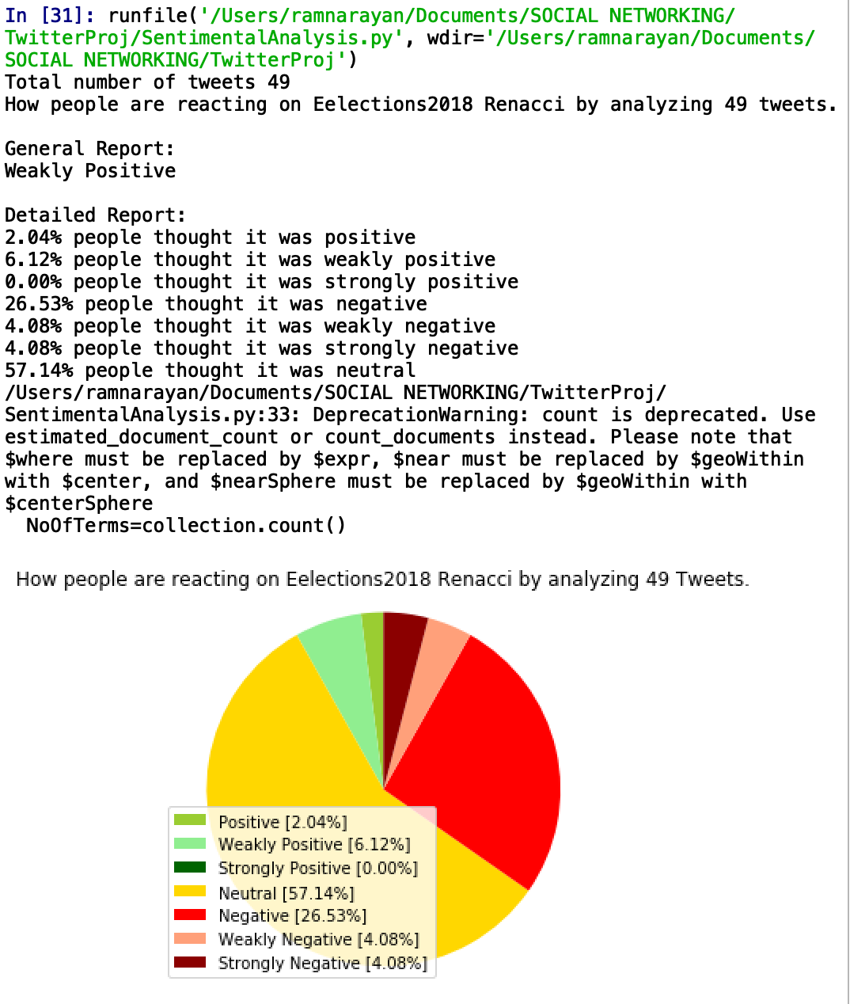

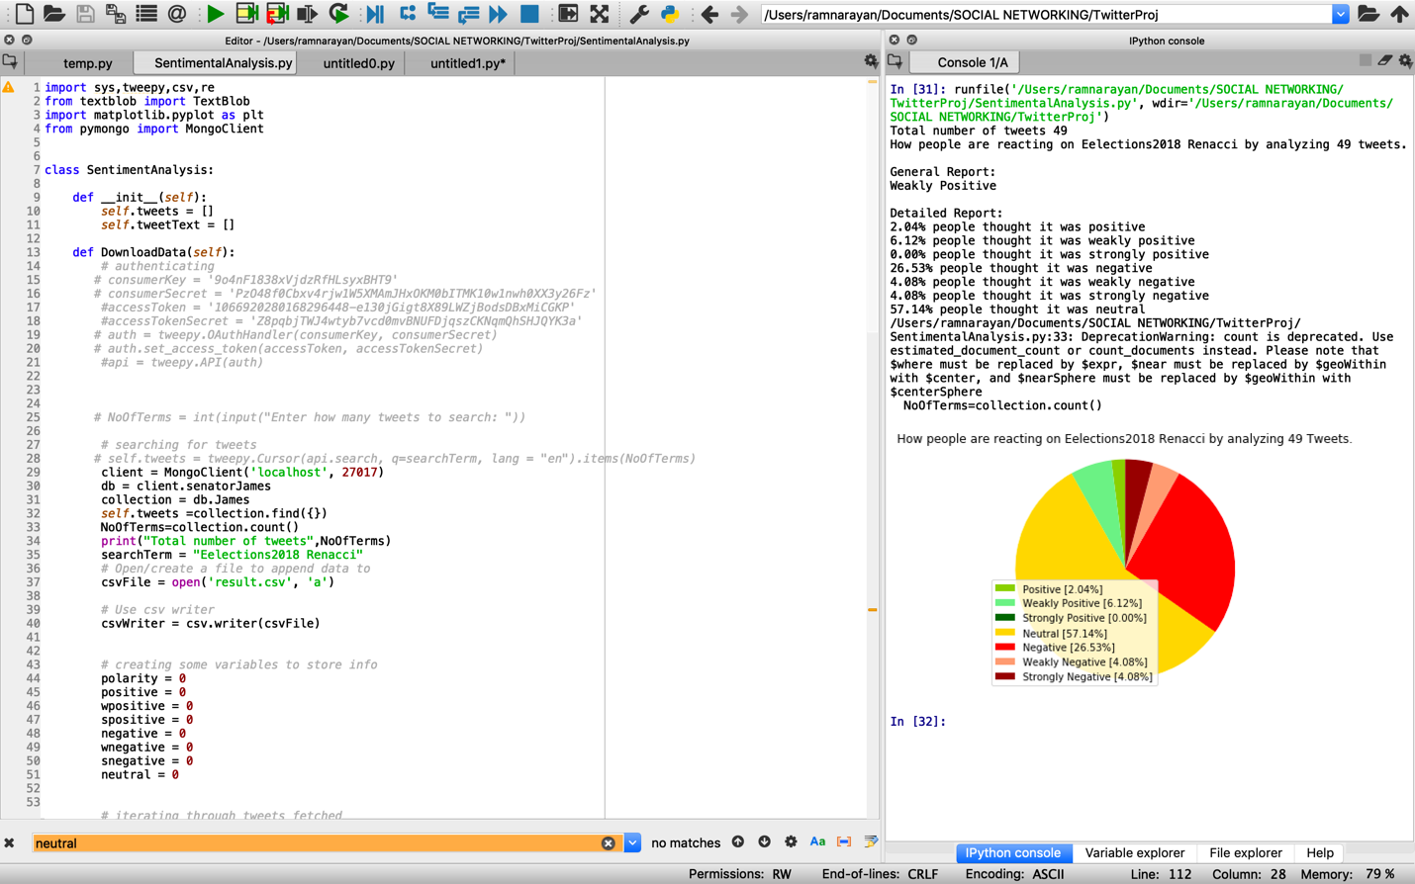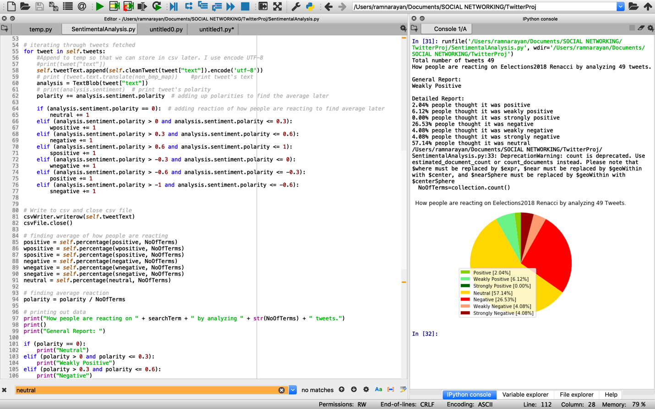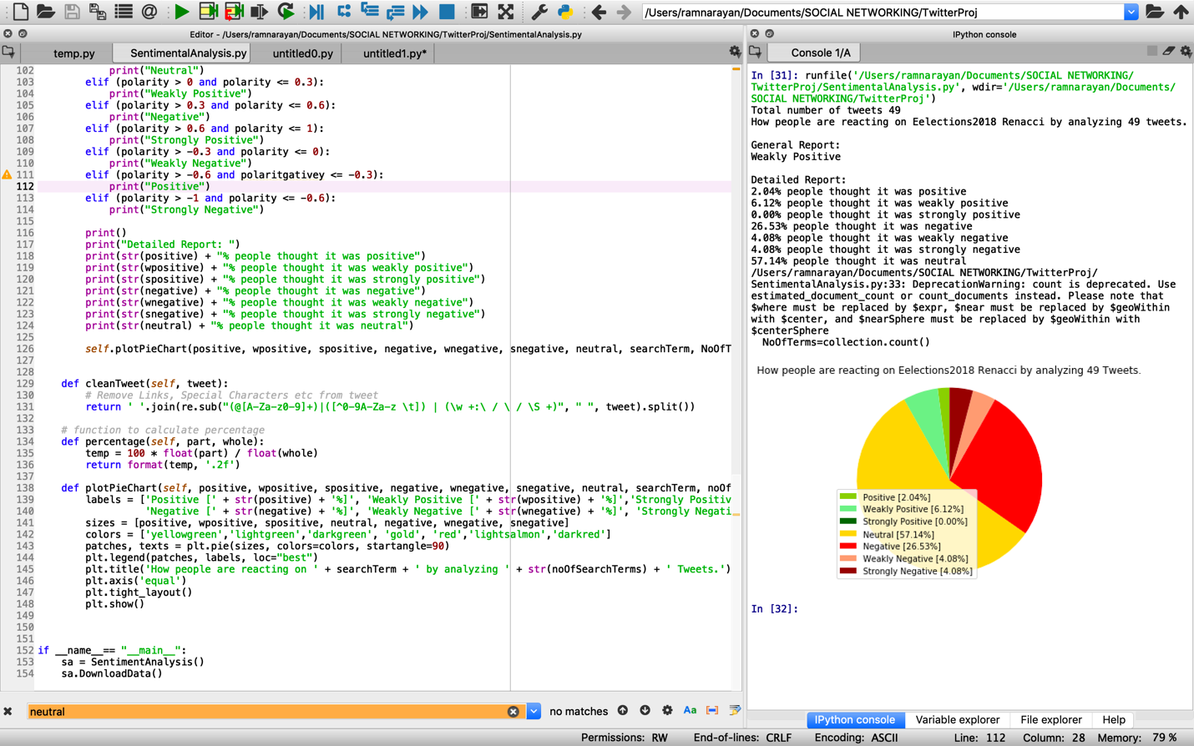

As we can see from the outputs, there are lot of positive talks for Sherrod Brown than Renacci which is an accurate result compared to the real-time result of united states Ohio senate elections where Brown won the elections.